# **Basic Design Principles Overview**

## **What Is Design?**

Do you have a favorite breakfast cereal? If so, have you ever looked at the bright, colorful design on its box? It's no accident that the box appeals to you. The words, colors, and pictures, were created by a purposeful process called graphic design.

**Graphic design** is the art and skill of combining words and pictures to convey ideas and experiences. It's a process important to fields like advertising, and it's all around us. If you've visited a website to buy something or read a magazine, you've experienced the effects of graphic design. Because graphic design uses visual elements to get ideas across, it's sometimes also called **visual communication**.

Graphic design is done by people called **graphic designers**, professionals with art backgrounds who have learned about important design ideas in order to effectively craft messages for print and digital media. Graphic design is also important to branding and developing company logos. The right message and image attracts consumers and ensures we keep buying products and services.

## **Basic Design Principles**

The way elements are positioned on a page or a digital ad isn't an accident. Effective graphic design considers elements like line, shape, and color. It also involves several key **principles**, or fundamental ideas that serve as a foundation to all design. Used in combination, these elements and principles help convey ideas. In the end, graphic design communicates a message or idea by using several important principles in combination.

Six important basic principles go into graphic design. Let's learn a bit more about each.

### **Alignment**

**Alignment** is the proper positioning of parts or elements in relation to each other. It doesn't mean they have to be in a straight line, just that they are placed in an ordered way. In graphic design, effective alignment helps designers create pleasing, well-organized compositions and avoid messy, scattered designs.

### **Proximity**

Related to alignment is **proximity**, or how close things are to one another. Proximity involves grouping elements like words, shapes, or images. Several elements near each other reinforce an idea or relationship and create a focal point for a design that draws the eye.

### **Repetition**

Designers also use **repetition**, or repeating elements like words, color, or a specific graphic treatment, to reinforce an effect. Repetition creates a rhythm in a design that helps get the point across. Have you ever seen an ad that repeats a word or phrase several times? It's there to make you notice and remember.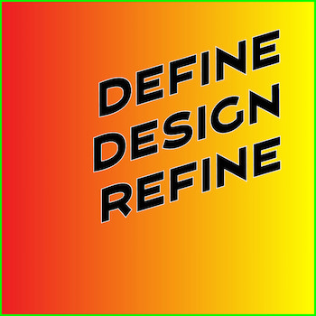

**Contrast**

Effective designs also use contrast. **Contrast** is the process of using two elements that are very different in opposition to each other. For example, designers may use dark colors against white or light colors, or large shapes against small. Effective contrast highlights important ideas and makes them stand out.

| contrast in graphic design |
| --- |

### **Balance**

Good graphic design should also have **balance**, or elements positioned to create a design with stability and structure. Each object in a composition has a visual weight. For example, in an ad with a series of squares, a large square would has more weight than a smaller square. Balance can be symmetrical, where

elements are balanced on both sides of the design, or asymmetrical, where a flow of elements from one side of the work to another creates a stable, ordered appearance.

### **Space**

Finally, **space** considers the area including and around design elements. Space can also help to balance a design. This principle involves positive and **negative space**, or the areas between and not including the images and words in a design.

Graphic designers learn all of these principles and keep them in mind when planning designs. By carefully and effectively aligning, balancing, and contrasting elements, they can create designs that catch our attention and spark our interest.